Cody Benkoski

Assignment 2

### [hk2327@wayne.edu](mailto:hk2327@wayne.edu)

Links:

* GitHub
  + <https://github.com/codyben/CSC-5991-Assn-2>
* DockerHub
  + <https://hub.docker.com/repository/docker/codybenkoski/csc-5991-assn-2>

Screenshots:

* Built the Docker image.
  + 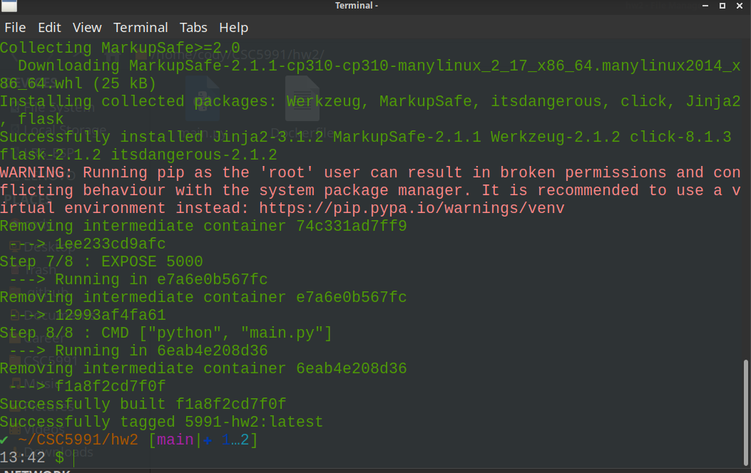
* Tagged & pushed image to DockerHub
  + 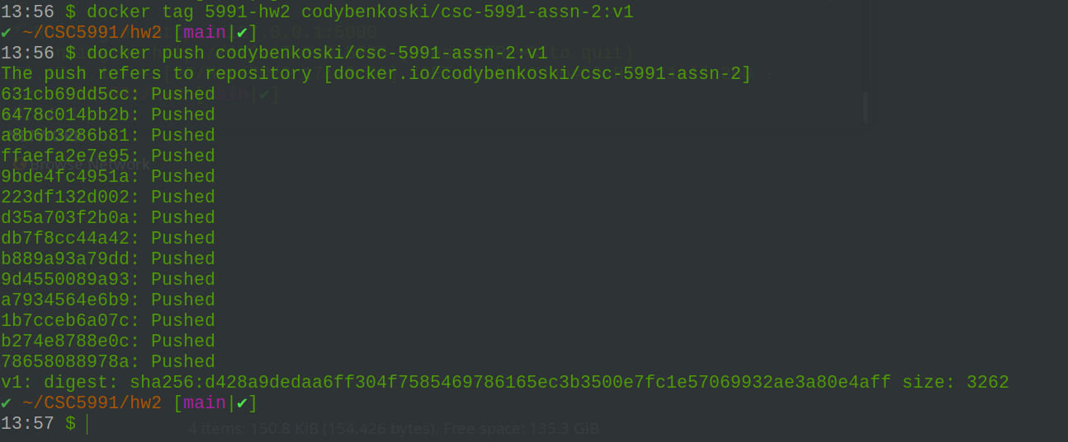
* Subsequently pulled & ran image from DockerHub
  + 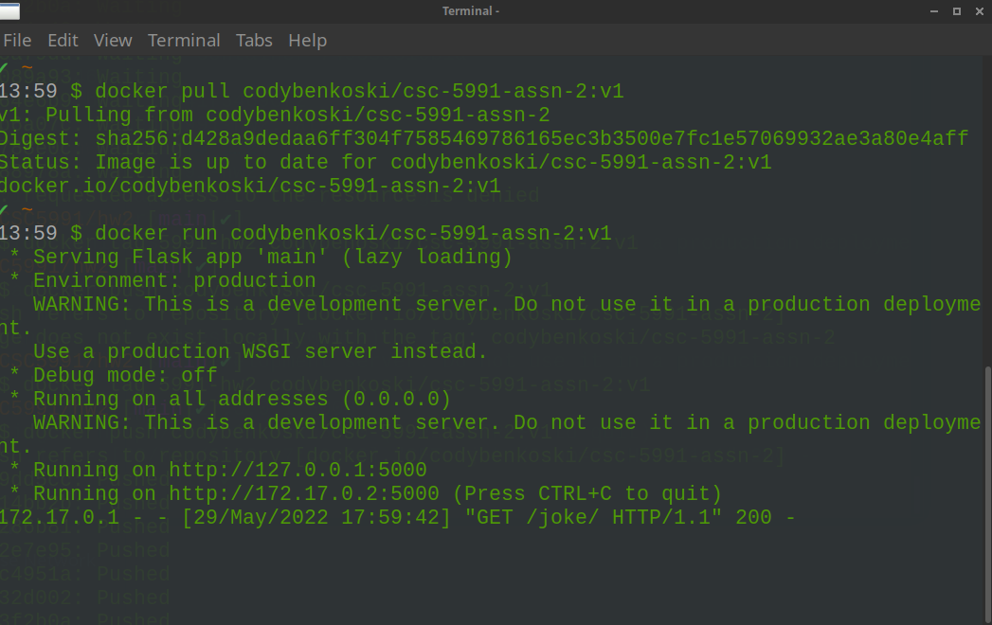
* Screenshots of application running
  + Request one (num=1) jokes
    - 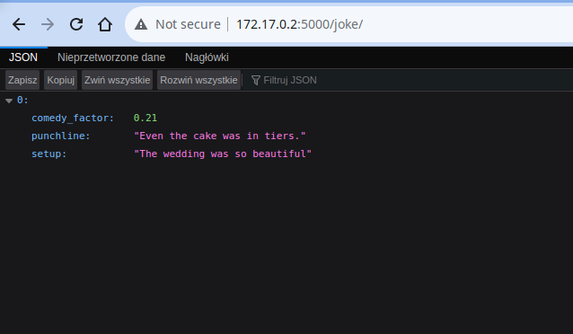
  + Request twenty (num=20) jokes
    - 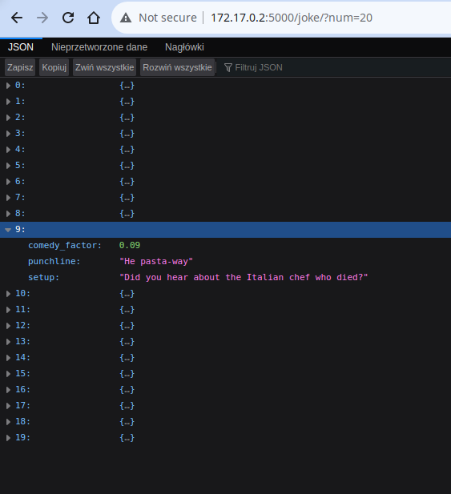

Notes:

* Format of response change from previous assignment to comply with the new description requesting a JSON array.
* Format of individual jokes is kept the same, since that didn’t have a specific requirement.